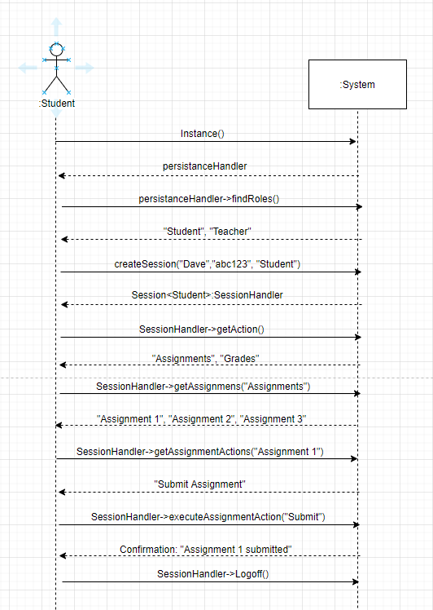

UC 2 Submit Assignment:

In this use case the student actor will submit an assignment. First the student will authenticate themselves to the system using their name “Dave”, password “abc123”, and role as “Student”. The system shall return a list of actions: Assignments, Grades. The student will then execute the action “Assignments” and the system shall return a list of all existing assignments: Assignment 1, Assignment 2, Assignment 3. The student will execute “Assignment 1” and the system shall return the assignment with the option to Submit Assignment. The student will execute the option “Submit Assignment” and the system responds with confirmation saying “Assignment 1 submitted”. The student will then logoff.